ecTA – Time & Attendance Management System – Online roster input interface
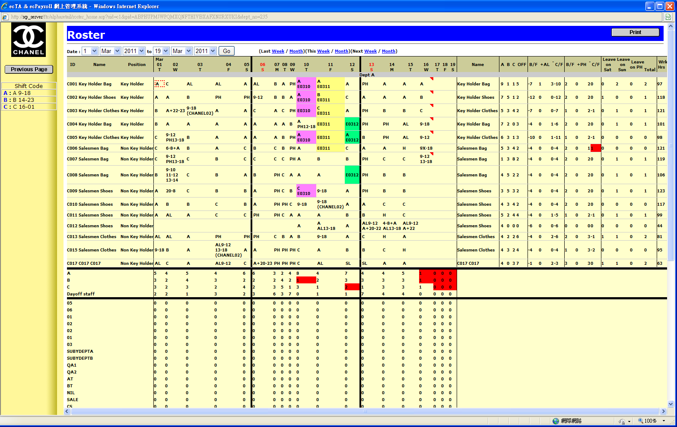
Logo

